## Diagonal Difference

Write a program that finds the **difference between the sums of the square matrix diagonals** (absolute value).

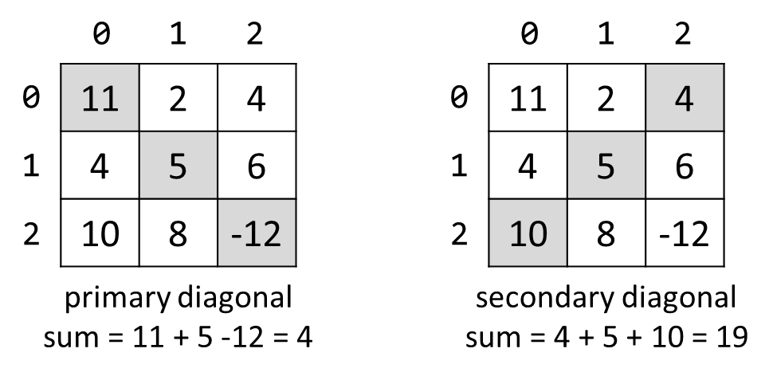

### Input

* The **first line** holds a number n – the size of matrix.
* The next n **lines** hold the **values for every row** – n numbers separated by a space.

### Examples

|  |  |  |
| --- | --- | --- |
| **Input** | **Output** | **Comments** |
| 3  11 2 4  4 5 6  10 8 -12 | 15 | **Primary diagonal:** sum = 11 + 5 + (-12) = 4  **Secondary diagonal:** sum = 4 + 5 + 10 = 19  **Difference:** |4 - 19| = 15 |